joseph roper

Salford City College | [Company address]

BTEC National 90 Credit Diploma in Creative Media Production

Unit 78: Digital graphics for computer games

Unit 78 – Digital Graphics for Computer Games

# Graphics

An image or text that you capture or create using a camera, scanner or a computer. With a computer you can manipulate it by changing the colour or size etcetera of the image. [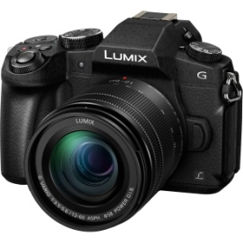](https://www.bhphotovideo.com/c/product/1280824-REG/panasonic_dmc_gm85mk_lumix_dmc_g85_mirrorless_micro.html)[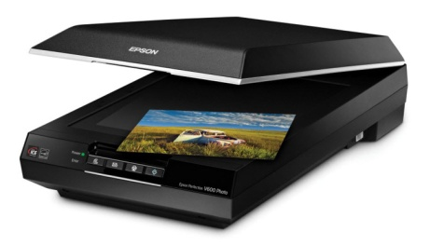](http://www.scanplify.com/best-35mm-film-and-slide-scanner-reviews/)[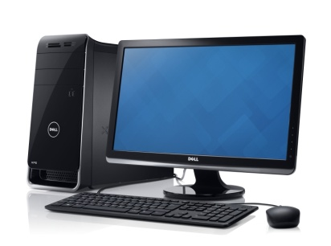](http://www.allwhitebackground.com/computer-white-background-images.html)

An image taken by film is known as a photographic print. Whereas an image taken by a digital camera is represented as 1’s and 0’s.

# Concept Art

[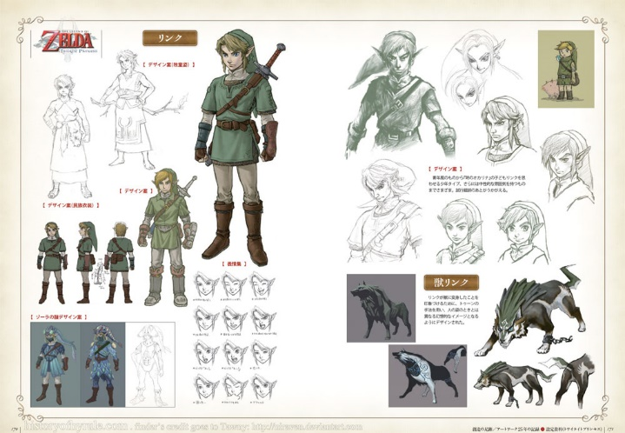](http://www.theconceptartblog.com/2012/05/07/hyhule-historia-zelda-25th-anniversary/)Concept art is used in pre-production to show ideas and in games design it is mainly used to show the developers preliminary ideas for characters and enemies in the form of drawing. Concept art is also used in films, animation and well everything which contains drawings such as architecture. Concept art is just illustrations that convey an idea, mood, character, colour scheme and or the overall style of the game. Concept art starts off as rough sketches and with time they are revisited and perfected/optimised and left as final ideas and are usually released to the public.

As you can see this picture shows the early stages of concept art and the final design for the character Link in The Legend of Zelda: Twilight Princess.

# Photorealism

These are hand drawn images, paintings and rendered images which look very realistic to the point where they look photographic. Photorealism is used a lot in the most recent games as it has become a popular form of gaming. As technology has evolved photo realistic games have become more advanced as the graphical capabilities of computers has increased. An example of a photo realistic game is the new Project Cars 2 it aims for a truly realistic feel and experience of driving a car.

[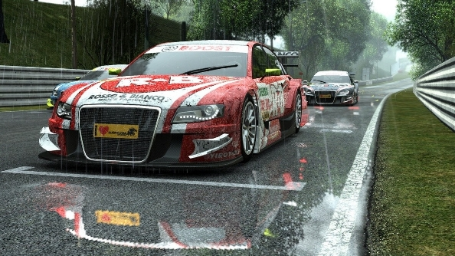](https://www.pcgamesn.com/project-cars/project-cars-2-is-now-in-full-production-by-the-entire-development-team)

# Cel-Shading

This is a form of rendering that mimics the style of comic books and appears to be hand drawn. Cel-shading contains cell-like segments which can be both solid or soft shaded which is filled with highlights and dark tones. Due to cel-shadings simplicity in shading it requires less memory than a photo realistic game meaning that it is easy for a computer to render the game with no lag.

[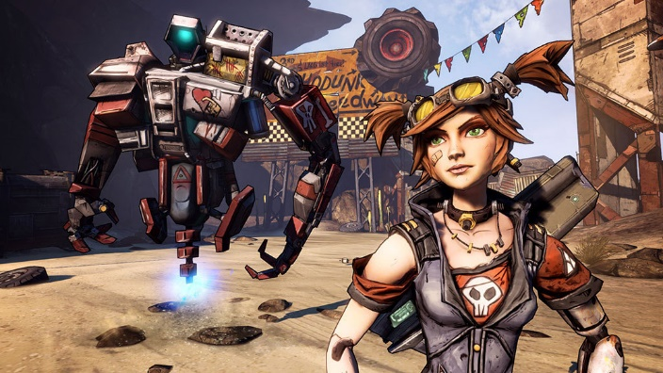](http://www.macgamestore.com/product/3544/Borderlands-2-Complete-Edition/) [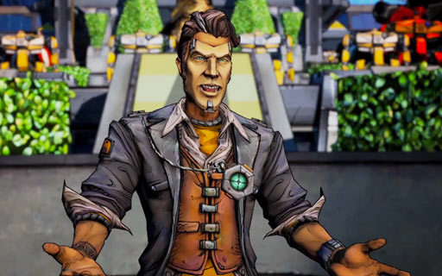](http://www.theoryofgaming.com/borderlands-2-one-year-later/)

A superb realistic cell-shaded game is Borderlands 2 introduced by the game development team “Gearbox”. The cell-shaded characters and environments in the game are highly detailed and filled with colour.

# Exaggeration

This is when someone exaggerates important or easily identifiable features. This is noticeable when looking at the main character of the game series Animal Crossing. The main character from this series has an exaggerated head this is because the creator wanted the user to concentrate on the character’s head when looking at him from a bird’s eye view.

[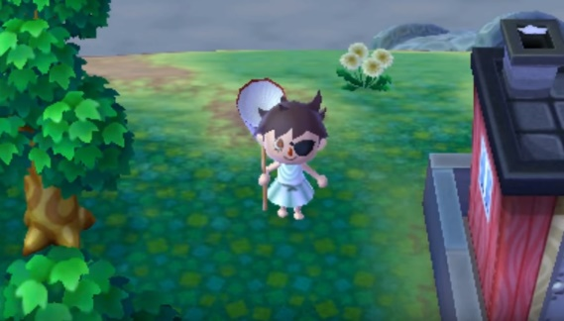](https://www.youtube.com/watch?v=RCJ_7Q8CqJ0&t=447s)[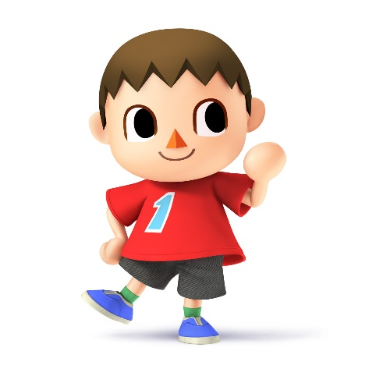](http://www.smashbros.com/en-uk/characters/villager.html)[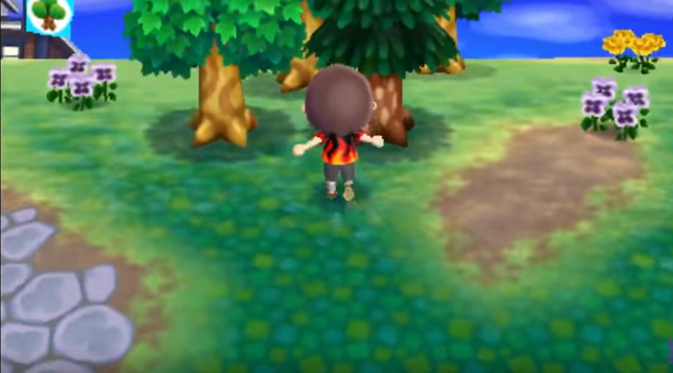](https://www.youtube.com/watch?v=RCJ_7Q8CqJ0&t=447s)

Although a game that uses exaggeration usually looks like a cartoon it is also used in most photo realistic games to portray the violence as over the top to intrigue the player and enhance their experience. An example of this type of exaggeration is shown in the game Resident Evil 4 as you can see from the picture in real life a shotgun blast to the head wouldn’t behave that way this was just implemented into the game to intrigue the player to carry on playing.

[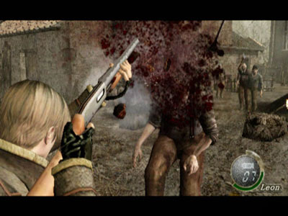](http://cube.gamespy.com/gamecube/resident-evil-4/577819p3.html)

# Anime/Manga

An art style originating in Japan which often exaggerates certain features of a character’s body and has a hand-drawn quality to it. This form of art style is most certainly expressed in the anime One Punch Man with the character Saitama’s exceedingly bald round head. Another example is from the anime series Code Geass as all the characters have huge eyes.

[](https://www.youtube.com/watch?v=ytOTwtA-Py8)[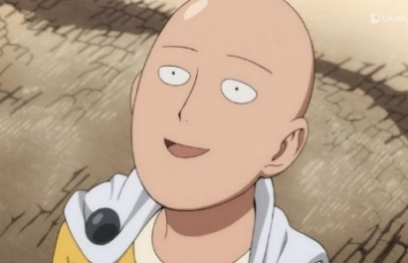](https://comicvine.gamespot.com/forums/battles-7/saitama-vs-thor-vs-superman-1800983/)

# Limbo Free Download Pc Game - Free Download Full Version ...Expressionism

This art style often uses symbolism and metaphors to portray physical things, concepts and emotions. Such as a black background could be portraying someone as feeling sad or depressed. The art form of expressionism originated from Germany and is used to convey certain moods, ideas and to show the world from a different perspective. An excellent use of expressionism in a video game is in the indie title Limbo in this you play as a child shrouded in darkness trying to find out what has happened from the perspective of this boy.

# Realism

Looks realistic but lacking embellishment or exaggeration usually is minimalistic. Similar to phot realism but often less detail. The reason it is not detailed and lacks stylisation is because this art tries to show tings truthfully. As you can see from this image it uses the realism art form as it is not trying to look good it is simply trying to describe what is happening in the picture and that is it.[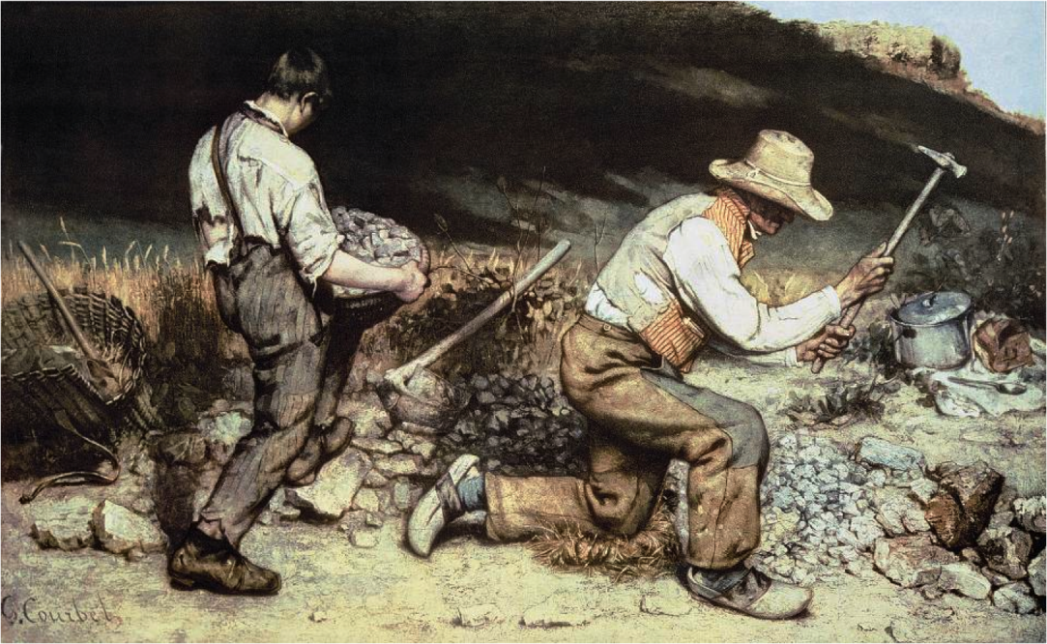](https://www.citelighter.com/art-architecture/art/knowledgecards/the-realism-art-movement)

# Image Resolution

Resolution refers to the number of pixels in an image. Resolution is defined by the width and height of the image as well as the total number of pixels in an image. For example, an image that is 1920 pixels wide and 1080 high or referred to as 1920X1080 contains 2,073,600 pixels. Another way resolution can be measured is by the acronyms DPI (Dots Per Inch) and PPI (Pixels Per Inch) the higher the DPI the larger amount of detail the image has. [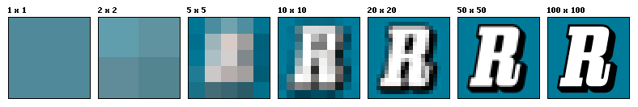](https://en.wikipedia.org/wiki/Image_resolution)

[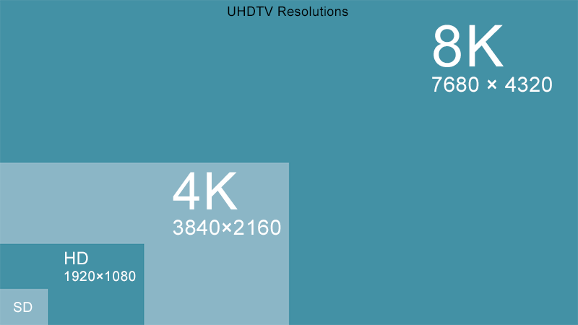](http://www.mediacollege.com/video/resolution/)

# Image Quality

The image quality is measured on how accurately the image represents the subject of the whole display. This can be defined by how well the brightness, contrast, resolution, geometry and colour matches the intended subject. As you can see from the photo lighting is usually controlled with camera lights and contrast is normally controlled with a white background, these can also be changed in programs such as Photoshop. [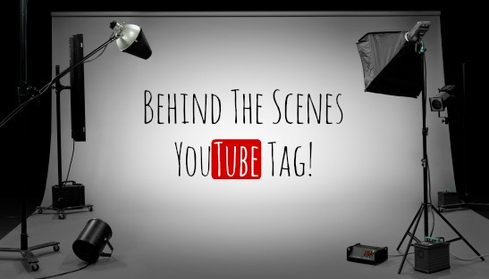](http://www.mamakatslosinit.com/2014/11/behind-scenes-youtube-tag/)

The quality of the image can also be manipulated “compression”. An uncompressed image is saved in a file format that doesn’t compress.

# Pixel Art

A form of digital art where images are edited on the pixel level. This type of graphics is mainly used in most old and/or relatively limited computer and video games. Most mobile phone games are pixel art type games. Pixel art is created in a raster based graphic such as MS Paint or Adobe Photoshop and uses bitmaps. An example of a game that uses pixel art is Undertale which uses raster based graphics as if you zoom in on one of the characters the image will lose quality. [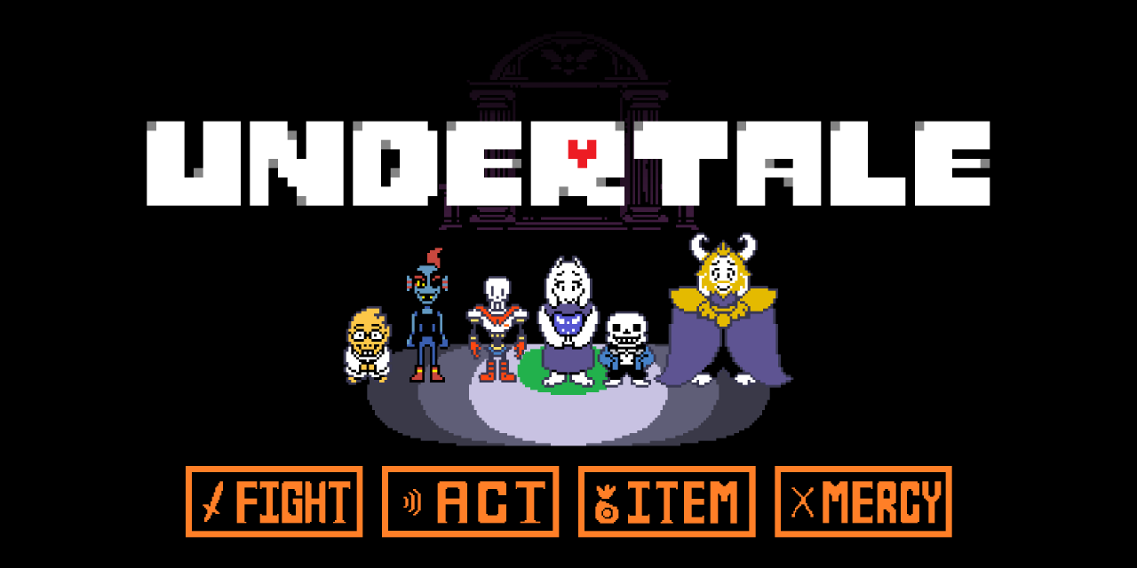](http://game-trends.com/undertale/)

# Types of Digital Graphics

There are many different types of digital graphics that can be used to portray a different visual styles and formats for a game.

## Raster Graphics

Raster Graphics or bit maps represents an image made of an array of pixels which is resolution dependant. Raster Graphics are generally most practical for photo – realistic images, but do not scale easily without loss of quality. Common file formats – JPEG –TIFF – GIF – BMP – PNG. An example of vector graphics in video games is with the original Mario as that used bit maps to create the characters so if you zoomed in onto Mario the quality would drop massively.[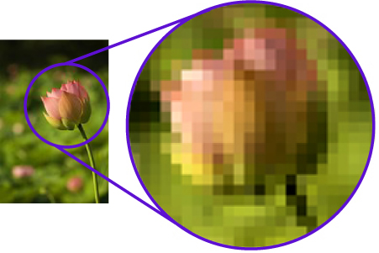](http://www.offsetprintingtechnology.com/2012/halftone-raster-reproduction/) [](https://www.reddit.com/r/AskMen/comments/4phsry/fighter_mage_thief_or_cleric_which_would_you_be/)

## Vector Graphics

Vector Graphics is the use of geometrical primitives such as points, lines, curves and shapes or polygons, which are all based on mathematical equations to represent images in computer graphics. Vector images are scalable meaning it retains its quality when zoomed in. They are made of small points named vertexes and paths. A vertex is a certain point within an image that puts a path in the given space. An example of a game that uses vector graphics is the new Mario game Super Mario Odyssey as you can zoom into the character Mario and it will stay the same quality and also as this Mario is 3D. [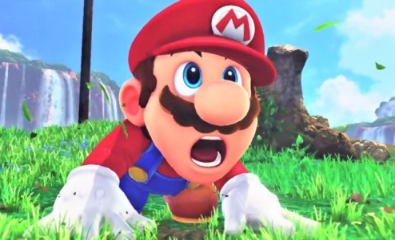](http://www.jeuxactu.com/super-mario-odyssey-trailer-de-gameplay-et-date-de-sortie-sur-switch-109745.htm)

# Sprite

[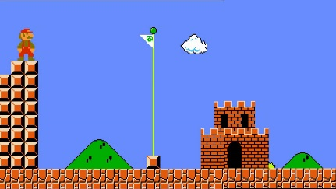](http://www.nintendo.com/games/detail/super-mario-odyssey-switch)A 2D or 3D character or object integrated in a digital graphic, it is created with bit maps or pixel art and is designed to be a part of a larger scene such as a world in a game. A sprite can be a static image or an animated graphic such as an isometric sprite. In terms of a video game an example of a sprite is any object in a game, it can range from Mario which is a 2D bit map to the flag pole/castle in Mario which is still a sprite but it just does something different.

[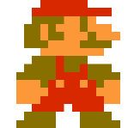](http://www.cracked.com/blog/chatting-with-mario-during-a-game-of-super-mario-brothers/)

# Isometric Sprite

[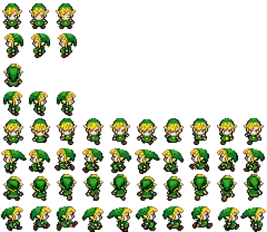](http://thomasyatesunit78.weebly.com/blog/2d-sprites)3D sprites are referred to as isomeric sprites which are basically 2D sprites that give an impression of depth to the single/player perspective isometric sprites are used in games such as Zelda. As you can see from the image it’s just a picture of Link at every angle such as front, back and side this makes it seem that Link is a 3D sprite where actually he is just a bunch of 2D sprites congregated into one.

# Character

[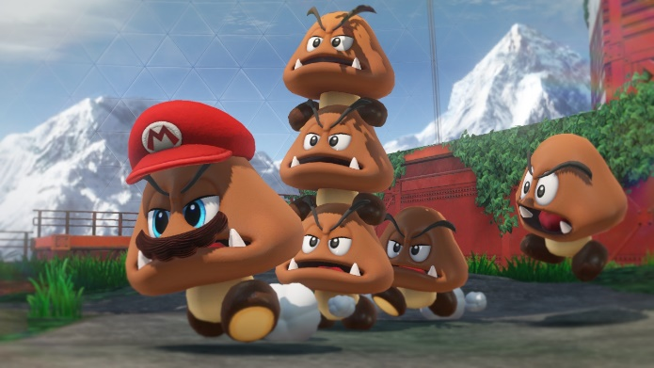](https://www.polygon.com/e3/2017/6/13/15793510/super-mario-odyssey-hat-costume-list-trailer-nintendo-switch-e3-2017)[](https://www.mariowiki.com/Goomba)[](http://www.nintendo.com/games/detail/super-mario-odyssey-switch)An entity or an object that takes part in a game which is controlled by a player. All characters are still sprites just sprites which can be controlled by the user so Mario or Sonic is a character in a game whereas Peach or Toad are not characters as you can’t control them. But because of the new game Mario Odyssey this rule is slightly defaced as in the game you are playing as Mario so he is a character and a goomba is an enemy meaning it is a weapon as it can attack Mario the character but you can also capture the goomba with your hat and play as the goomba so then the goomba will become the character.

# Weapon

This is an object in a game, by obtaining or getting in control of it can give you access to higher levels, items, power ups/abilities, knowledge. So considering that an object/sprite that gives you knowledge is a weapon the compass out of Zelda is supposedly a weapon as it gives Link knowledge about the dungeon. Also a koopa or goomba from the game series Super Mario Bros act as weapons as they give Mario less damage when Mario and the koopa/goomba come in contact.

[](http://vsbattles.wikia.com/wiki/Koopa)[](https://www.mariowiki.com/Goomba)[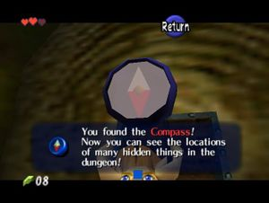](https://strategywiki.org/wiki/The_Legend_of_Zelda:_Ocarina_of_Time/Getting_Started)

# Vehicle

[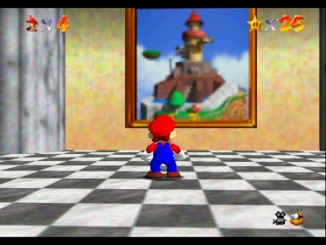](http://www.neogaf.com/forum/showthread.php?t=441073&page=4)An object/sprite used to transport a character to different places of a video game. So considering a vehicle just transports the character that means that the paintings in Super Mario 64 are a vehicle as they take Mario to new levels/worlds.

# Environment

[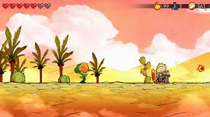](http://nintendotoday.com/wonder-boy-switch-tips/)A place which a character resides in such as a desert or jungle this can be dependent on different levels or areas of a game. Such as in Wonder Boy: The Dragon’s Trap there is a desert environment. The environment effects the background, enemies, and floor as you can see in the images. In the desert level the background has pyramids cacti and palm trees, the floor is sun bleached, cracked stone with sand on it and the enemies are sun flowers.

# Texture Art

[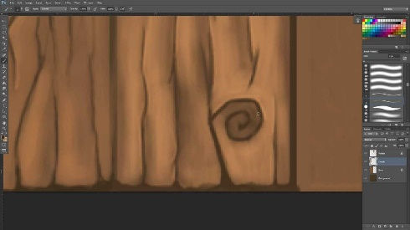](https://www.youtube.com/watch?v=o32zADYz8uE)Texture art is a 2D skin that is wrapped around a 3D object/sprite to give it a certain appearance of something such as having texture art of bark and wrapping that around the trunk of a tree to make it look like a tree. So this image/skin would then be placed on a tree and or a wooden door to make it look like the intended object.

[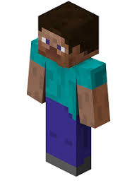](http://www.fotolip.com/minecraft-steve-6268.html)A perfect example of texture art is from the game Minecraft as you can make your own skin for your very own playable character. As you can see from the image it is a 2D skin which when imported into the game will wrap around the character to look like this.

[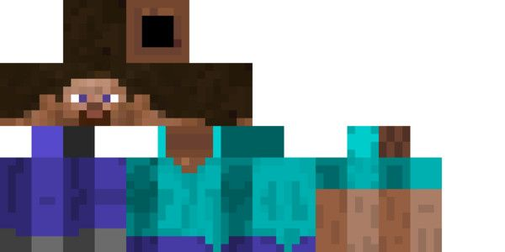](https://www.pinterest.com/pin/297589487852929597/)

# Background Graphic

[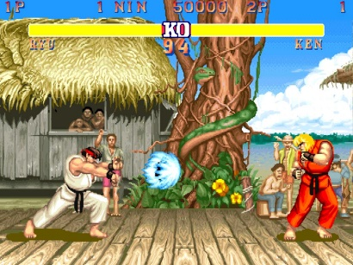](http://scoop.previewsworld.com/Home/4/1/73/1016?articleID=174718)This is a non-intractable display/image in the background of a game, it is placed there to set the scene/environment of the certain part or level of the game you are in. The background art should match the rest of the style of the game so it doesn't look out of place and blends in so the user isn't distracted while playing the game itself. Background graphics in games are constantly evolving such as in the 1990's the backgrounds were usually detailed pieces of pixel art like in Street Fighter II: The World Warrior, this background is a complete background as it covers all of the screen and doesn’t change acting as a backdrop. There can be other background graphics such as: cut-scene backgrounds, 2D tiles, 3D buildings and other objects, level backgrounds and finally environment art. Nowadays the preferred method of making backgrounds is to use digital methods by using programs such as the well-known Photoshop. Another example of a phenomenal background is from the game Superbrothers: Sword & Sworcery EP this game like Streetfighter uses pixel art even though it was made in 2011 which is rare as pixel art games are uncommon nowadays in the era of photo realistic and graphic intense games. The thing that sets Superbrothers apart from other pixelated games is that the background changes with the weather such as if it is windy the bushes will rustle and the light shining on the leaves in the bushes will flicker showing that it is windy as the leaves are moving.[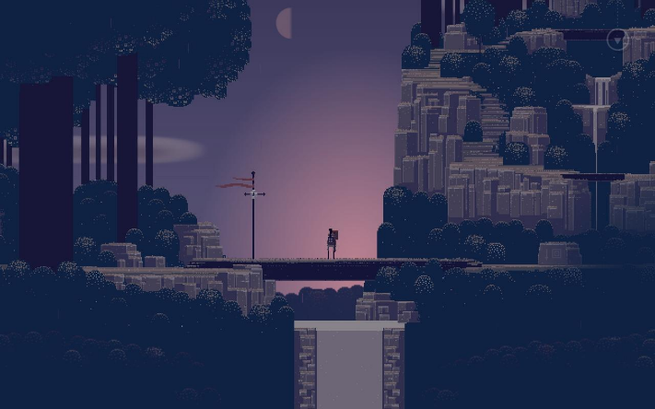](https://play.google.com/store/apps/details?id=com.capybaragames.sworcery)[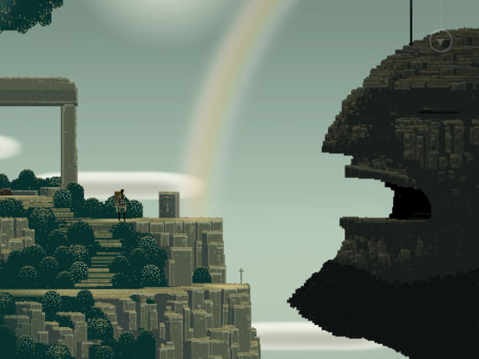](https://itunes.apple.com/us/app/superbrothers-sword-sworcery-ep/id424912055?mt=8)

# In-Game Interface

The in-game interface is just like the HUD accept you can interact with it. A good UI is meant to provide the user with the information they want to know and then disappear such as the leader board/score board when you hold tab in the game Counter-Strike: Global Offensive it shows where you are placed in the team how many kills and deaths you have and then once you let go of tab it disappears like a user interface should. Plus, on the leader board/score board you can right click on a player’s name and block communication with them and or report the player for hacking or griefing (the act of irritating and angering people in video games).

[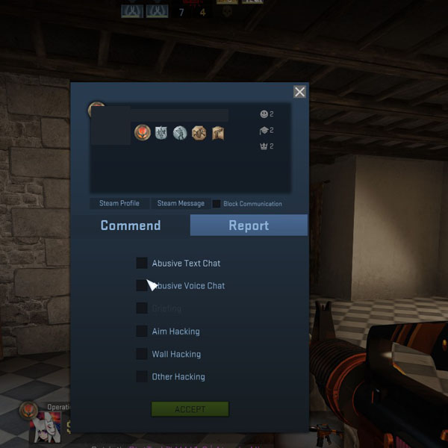](https://steamcommunity.com/sharedfiles/filedetails/?id=294510159)

[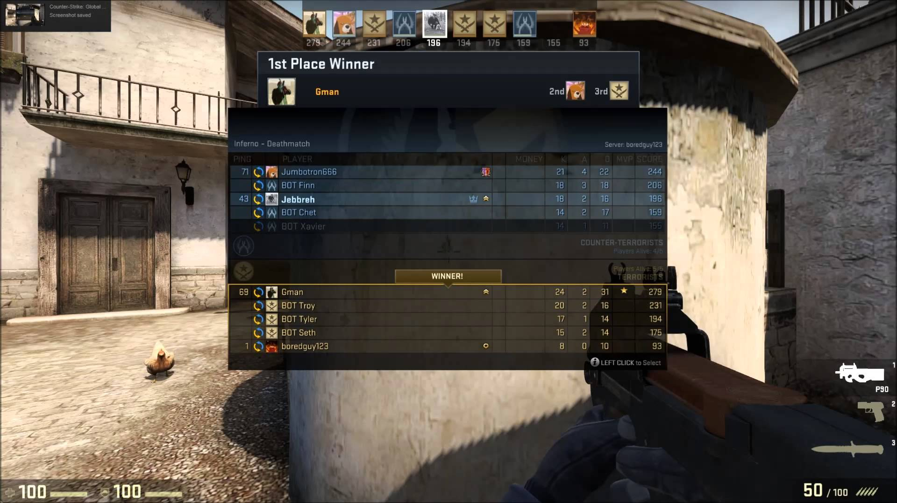](https://www.youtube.com/watch?v=jSVpysWHi_U)

# Head Up Display

Head Up Display or more commonly known as the HUD is a method of giving the user information about the character or game through images on the screen such as in the game Counter-Strike: Global Offensive. The reason it is called the HUD is because they are similar to the head-up up displays used in modern aircrafts.

As you can see the HUD in this game shows information such as how much health and armour the user has.

[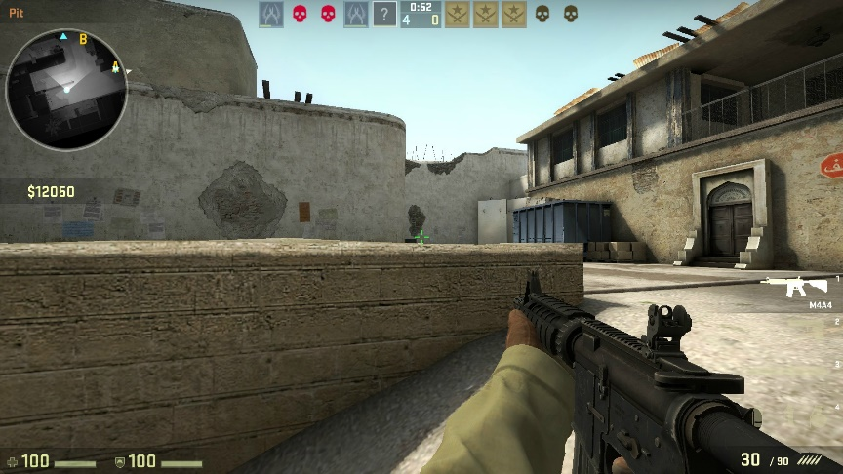](https://www.licente-jocuri.ro/counter-strike-global-offensive-steam-cd-key.html)

As you can see the HUD in this game shows information such as how much health and armour the user has.

Also the HUD in this game presents other information to the user such as how much ammunition the user has in their gun.

Also the HUD in this game presents other information to the user such as how much ammunition the user has in their gun.

As you can see the HUD in this game shows information such as how much health and armour the user has.

# Print Media Art

[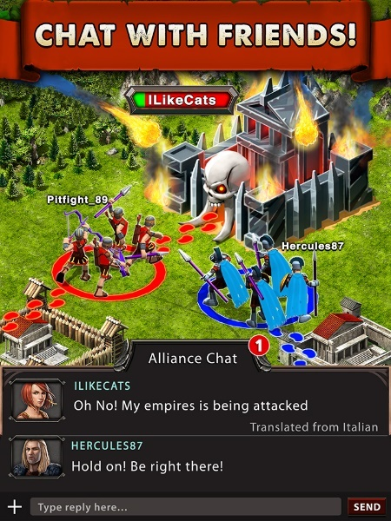](http://www.gameofwarapp.com/)The purpose of print media art is to promote the game what you are trying to sell it is meant to be put on posters and box art for the game to make it pop and stand out from the competition. Businesses usually hire an artist to make this rather than taking an image out from the game is because the game might not look that good graphics wise so they need good looking box art to initially interest the potential buyer and get them hooked. Also the practice of doing this is usually frowned upon it is still used frequently in the gaming industry. An example of this practice is seen in the mobile game known as Game of War: Fire Age as you can see from the poster of the game it looks stunning and seems like a graphic intense game however when you see the actual gameplay it is very disappointing and just looks like a bad clone of every other mobile game. It is very misleading.

[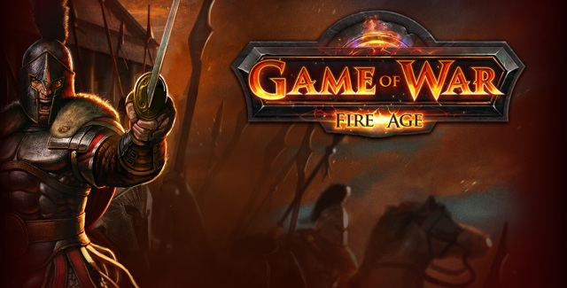](http://www.alltechfeed.com/game-of-war-fire-age-for-pc-windows-laptop/)

# Computer Game Graphics

Graphics are the simple rendering techniques that allow us to display images a particular way on screen. Examples of computer game graphics are self-shadowing, normal mapping, subsurface gathering and or tessellation. Better graphical capabilities allow you to display more polygons or do more detailed shadowing and lighting effects. Overall a better graphical capability allows for more fidelity.

[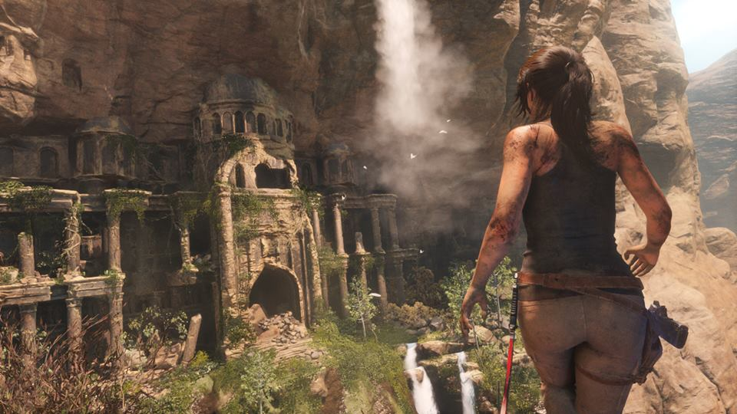](https://www.primagames.com/games/rise-tomb-raider/walkthrough/rise-tomb-raider-mountain-peak-find-prophets-tomb)Graphical capabilities of games over the years have improved massively starting off with simple text based games such as games created on Twine to the nowadays impressive highly developed photo realistic games such as Rise of the Tomb Raider which is a spectacular game. Each genre of games each have varying degrees of graphical capabilities. This is because a 1st or 3rd person open world game will need a powerful graphics card to render the game seamlessly to the player without any spikes in the frame rate making the game seem to run smoothly to the user. Whereas a 2D pixel art game such as the popular game Undertale will not need any special equipment to run as it is easy for a computer to run there is less information for the computer to digest in order to play the game.

# Pixel

A pixel is a minute area of illumination on a displayed screen. One of the many from which an image is composed of. Pixels are usually recognised as little squares on a screen however they can also be displayed as small dots or lines. Pixels usually follow the colour range of RGB which stands for Red Green Blue but it can be extended to ROYGBIV (Red, Orange, Yellow, Green, Blue, Indigo and Violet). The number of pixels displayed within an image is called the resolution. For example, a 1080p video means it is displaying 1080 pixels the same goes for 720p, 480p and 360p the most common number of pixels usually displayed on a screen in your everyday life. The difference between 480p and 720p is that the greater the amount of pixels the closer the image will resemble the original.[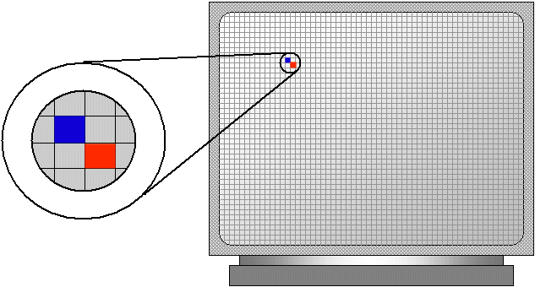](https://stackoverflow.com/questions/600374/what-is-a-pixel-px-in-css)[](https://forums.oculus.com/community/discussion/6992/no-more-screen-door-with-dk2-right)

# File Extension

A file extension or more commonly known as a suffix is a name given to a certain file or document added after the user named the file for example it would go Document (file name).doc (or anything else like jpeg). The most common file extensions are .jpeg, .pdf, .doc, .txt all of these are abbreviations such as .doc means document and .txt stands for readme.txt. File extensions are needed in order for the computer to identify the file and open it up with the right program.

[](https://www.file-extensions.org/)[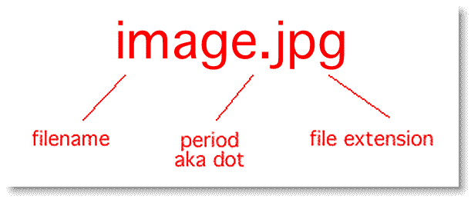](http://socialnetworkinglab.com/web-image-extensions/)

# Compression

Compression is needed to decrease the sizes of files so you don’t run out of storage, it does this by using a certain technique to remove any unnecessary data of an image. The most common form of compression is to zip a file by zipping a file it gets rid of all unnecessary information the file may have.

A way of decompressing a file is to use WinRAR or WinZip which will get the file back to its original size and if done correctly will be identical to the original copy. You can also compress multiple files at once.

[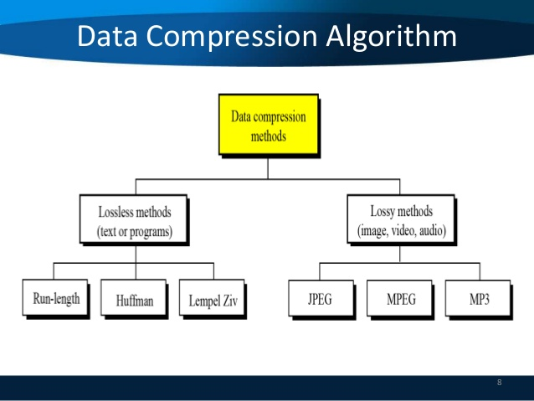](https://www.slideshare.net/sherifghoname/data-compression-28115182)

## Lossy

[](http://www.makeuseof.com/tag/all-you-need-to-know-about-video-codecs-containers-and-compression/)This is a type of data compression which uses technology to delete unnecessary information which makes pictures have less quality. This is why word documents and other types of text documents don’t use lossy as if they did then when the user reopened the file there would be words missing. Vector graphics and JPEG files use lossy compression.

## Loss Less

This allows you to compress a file and still keep everything, all the data that is on that file so if you save a music track with lossless compression when you open it up and play it, nothing will be missing and the song will have everything in it. Whereas if you were to save a music track using lossy compression and then replay it usually wouldn't sound the same as there would be a loss of audio quality. It manages to do this by eliminating redundant information or shortening information such as if in picture multiple pixels are the same colour it will code it so there are 45 blue pixels instead of saying “blue pixel, blue pixel, …”. Raster graphics use loss less compression.

# Image Capture

[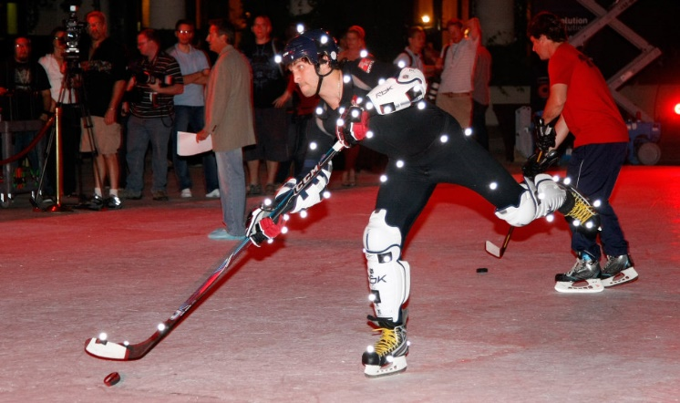](https://www.easports.com/nhl)[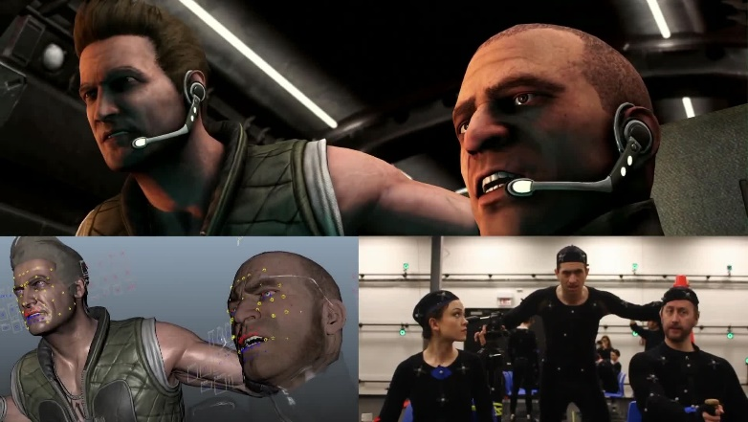](https://www.youtube.com/watch?v=CwtzLO3KQD4)Image capture is the method of recording something accurately with pictures. This is usually done with photographs or video recordings. A form of image capture is photo realism which uses HD (High Definition) images scanned through a computer to be used in computer games such as for textures. However, photogrammetry improves on photo realism as it again takes a lot of high definition images of a single object although this time the images of the object are then overlapped with a specific software in order for it to look real in a game such as an apple. Another form of image capture is motion capture this is used to recreate certain movements of the body such as the face including the more important mouth and eyes and put them in a game to animate a character making the game seem very realistic. The method for motion capture is to have actors wear special suits embedded with tons of censors, then they will ask the actor to perform a certain action and that will then be recorded on to a computer ready to be implemented into a game. However, motion capture is very expensive although that is counteracted with the positives such as the believable human bodily animations and it is a quicker method compared to computer generated animations.

# Optimising

Optimising is in other terms the method of perfecting work which basically means in the gaming industry fixing problems/bugs in a game. Optimising is the most useful and needed thing in the gaming industry as without it games would never be finely tuned and would have a lot of game breaking bugs. Optimising is most commonly used towards the release of a game to make the last finishing touches and to make sure the game runs as smoothly as possible upon release.

[](http://www.cracked.com/article_20261_6-unintentionally-hilarious-glitches-hidden-in-video-games.html)A good example which shows why optimising is needed is the game Sonic the Hedgehog (2006) or more commonly known as Sonic 06 this game was not optimised in the slightest due to time constraints and due to this the game suffered from game breaking glitches and a lot of them at that but because of this it is the worst Sonic game in history and viewed as one of the worst games of all time.

[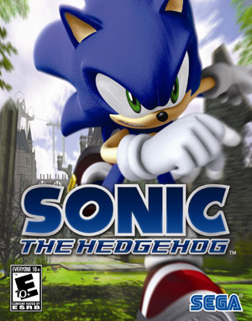](https://en.wikipedia.org/wiki/Sonic_the_Hedgehog_(2006_video_game))

# Storage of Image Assets

This is a main hub for everyone in a games development team to access data such as images, sounds and other documents. A lot of work is transferred through this over the internet so only small files can be sent over such as jpeg, tiff and giff files. However, if the image is large in file size for example a game texture when sent over it will be compressed and loose quality. It would usually look like this picture. [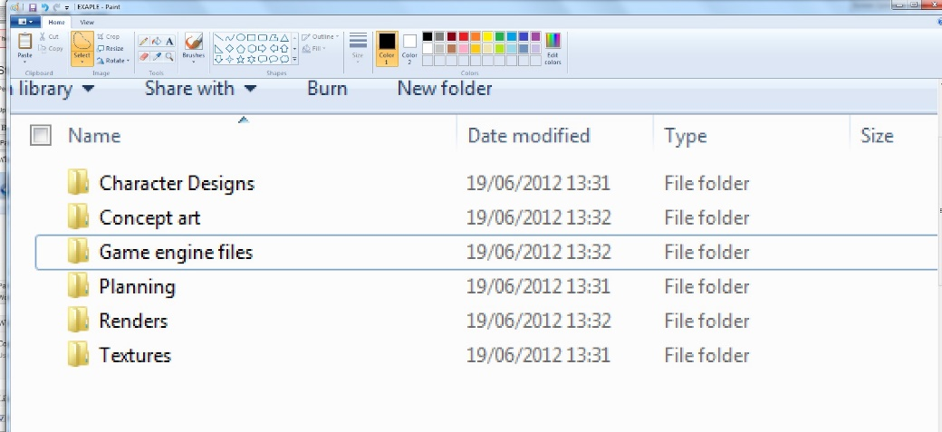](https://twinlance7.wordpress.com/unit-78/storage-of-image-assets/)

File Naming Convention

A file naming convention helps people to organise their documents making it easier to identify certain files that contain information you are looking for. A good file naming convention can help you and others working with you. A good example of a file naming convention is one my teacher told me to use and it usually looks like “L3-Y1-U78-JKR-Task 1”. So “L3” means level 3, “Y1” means year 1, “U78” means unit 78 and “JKR” are my initials. [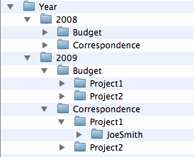](https://lsntap.org/book/export/html/2961)

Asset Management

Asset Management plays an important role in games development as if the assets are not managed and stored correctly everything will be unorganised which may result in losing work, sending incorrect files and more importantly time will be wasted trying to search for files. That’s why resources should be managed in both short term and long term.

An example of short term management is to keep the amount of windows on a browser to a minimum as if a bunch of windows were open it would be inefficient when trying to find a certain tab/piece of work causing time to be wasted which is never good in any business. Secondly the computer running the browser might not be able to handle all of the windows causing it to become slow and unresponsive and worst case scenario it could turn off causing work to be lost. Therefore, it would be more efficient to keep browser windows open to a minimum meaning there will be less clutter on the screen making it easier to manage. As you don’t want your browser to look like this.



A perfect long term management method is to make sure files are stored in the correct place to do this a library of folders should be made which are name accordingly to the content inside. This will make it easier in the work place to find certain files which are needed for work.

Another long term management method is to make regular backups of all work in case work is lost. These backups should be dated so it is apparent how old they are. Old backups that are irrelevant should of course be deleted to save space. A perfect example of why backups are important is with the movie Toy Story 2 as this movie was actually never going to be released as while working on it Pixar was near to completion when suddenly there was a server error and huge chunks of the movie was deleted and Pixar realised they couldn’t redo the movie so they were going to scrap it but luckily someone working from home had the entire film backed up on her computer and well as you know they were able to release the film in time all because of one backup.

[](http://www.onepointhosting.co.za/how-to-backup-your-data/)  
  
I acquired this information previously from an excellent YouTube channel this is the video link.

<https://www.youtube.com/watch?v=Hhr681TpZac>

### Sources

All links for pictures are on the pictures if you just hover over them with your mouse.

<https://techterms.com/definition/sprite>

<https://georgepollboa.files.wordpress.com/2012/09/unit_78_digital_graphics_for_computer_games.pdf>

<https://www.slideshare.net/munroAnimations/unit-78-digital-graphics-for-computer-games-15617717>

<https://prezi.com/jaod7qyjo3kc/unit-78-task-1/>

<http://jademulaghton.blogspot.co.uk/2014/10/unit78-digital-graphics-for-computer.html>

<http://thomasyatesunit78.weebly.com/blog/2d-sprites>

<http://unit78ed.blogspot.co.uk/>